**CLVD6221**

**Part 2**

**ST10390381**

**Screenshots**

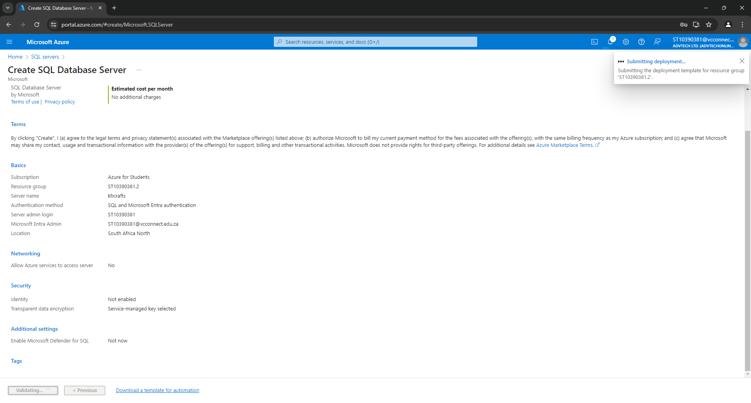

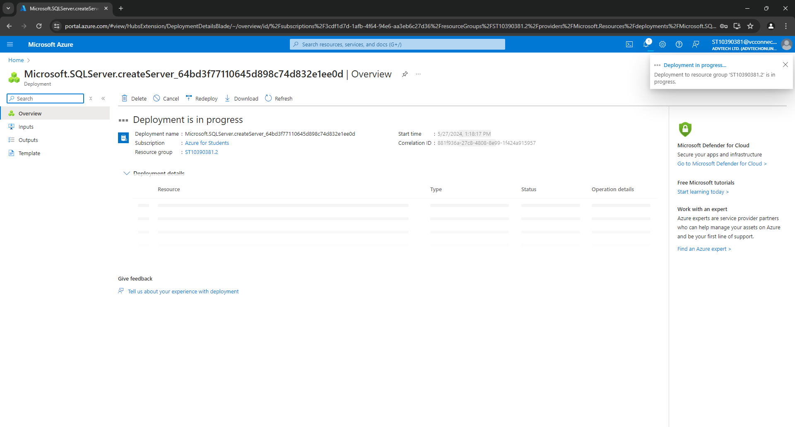

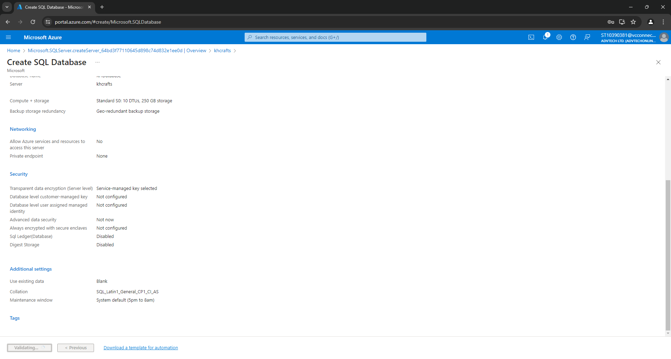

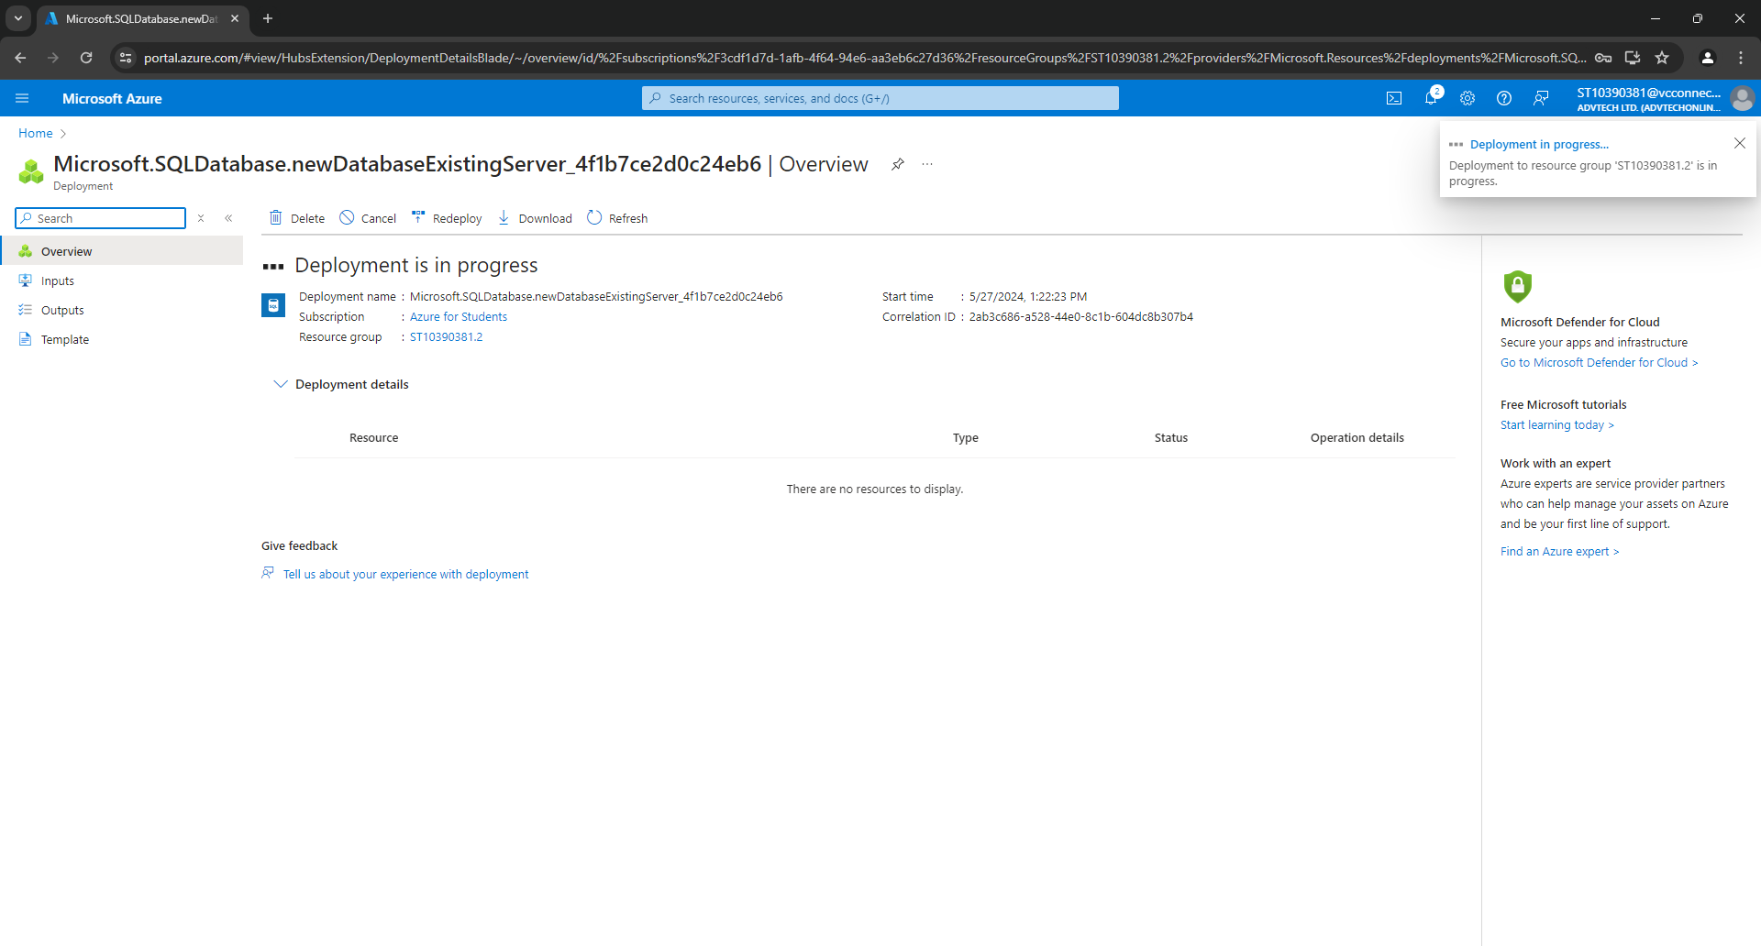

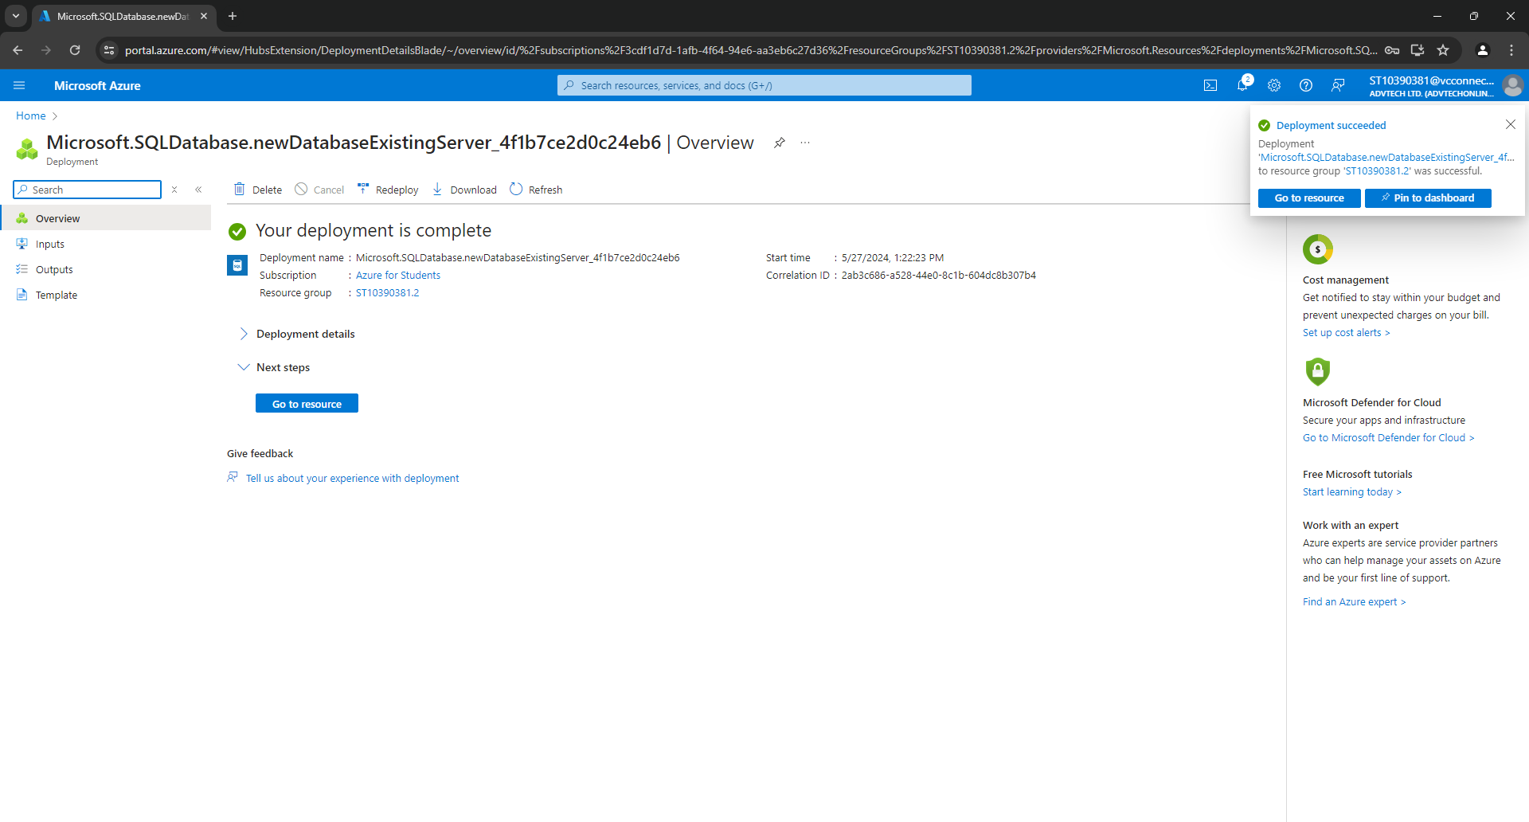

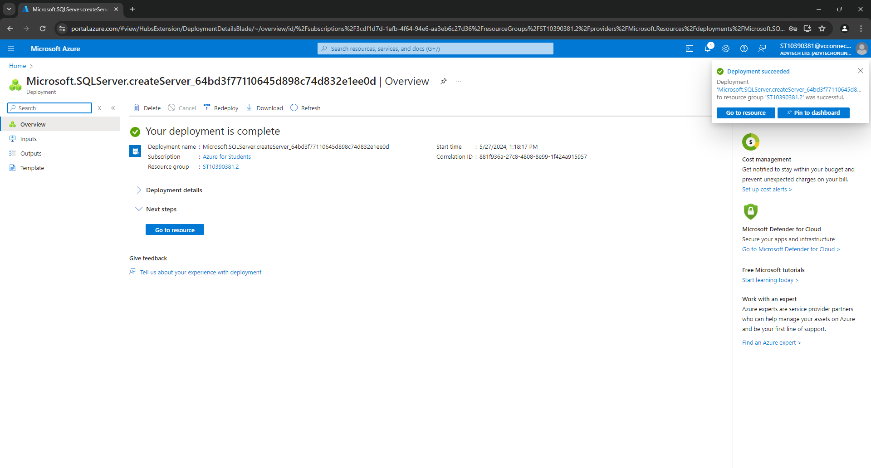

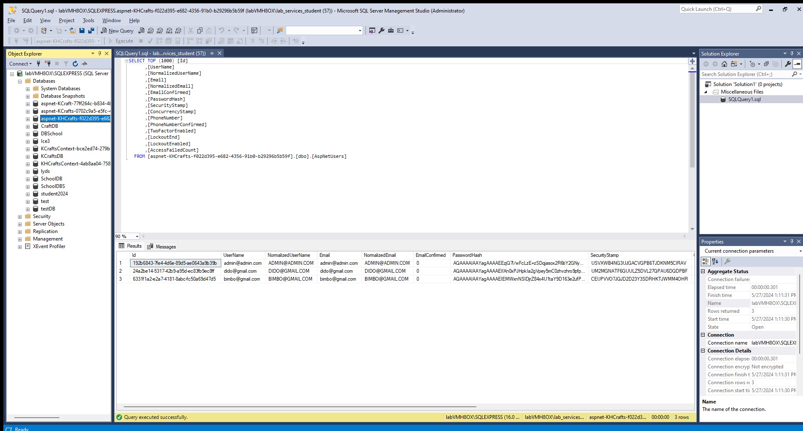

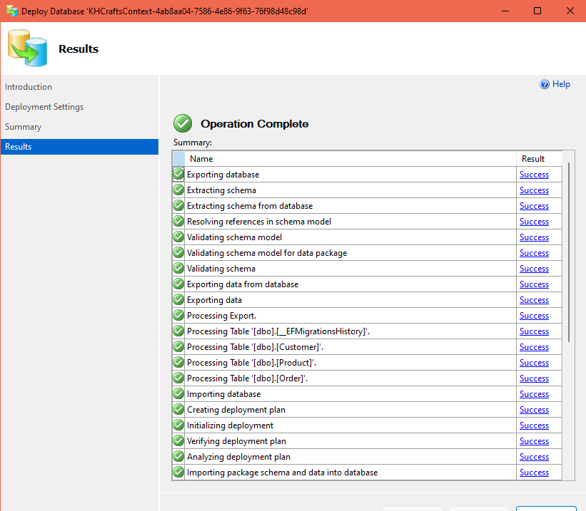

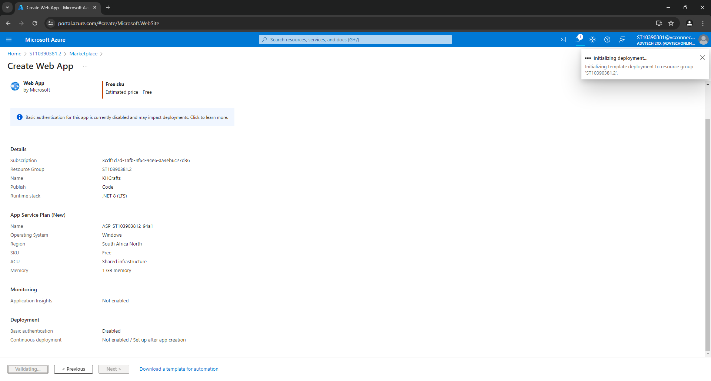

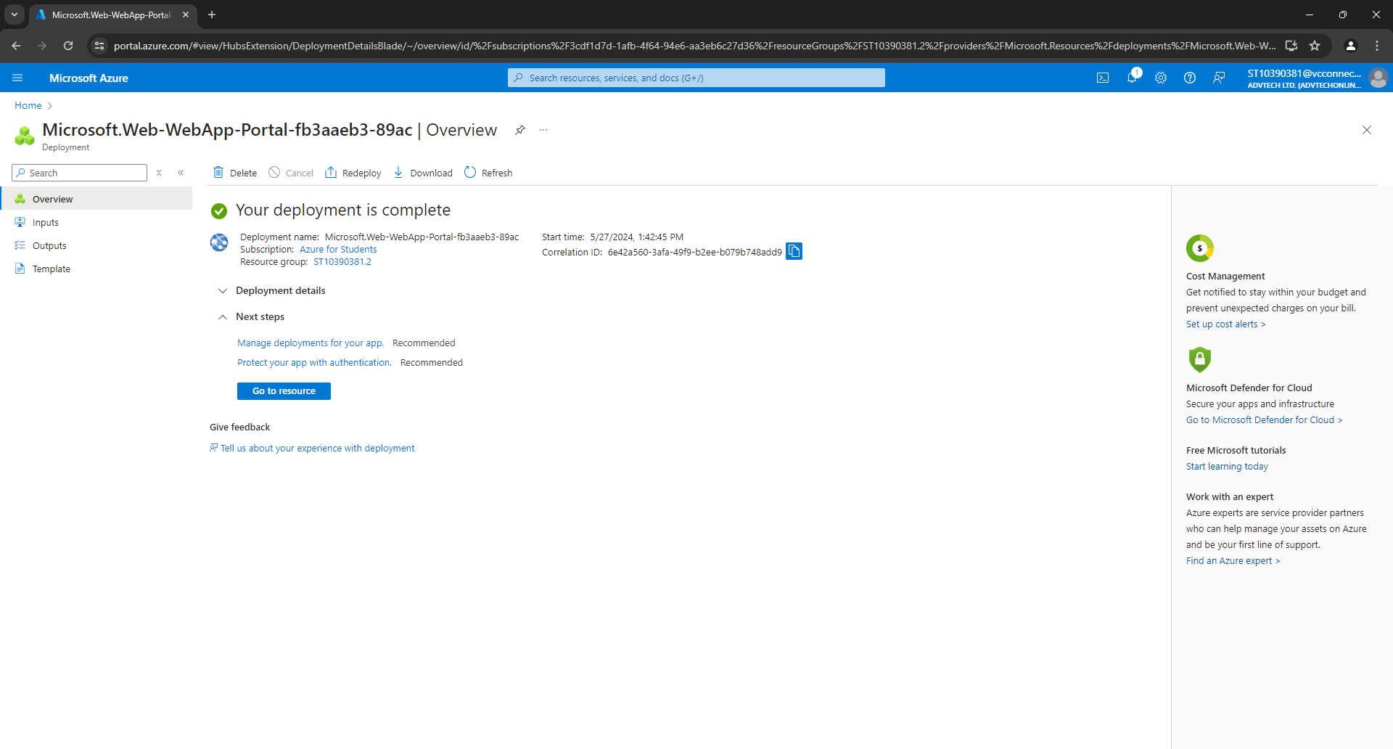

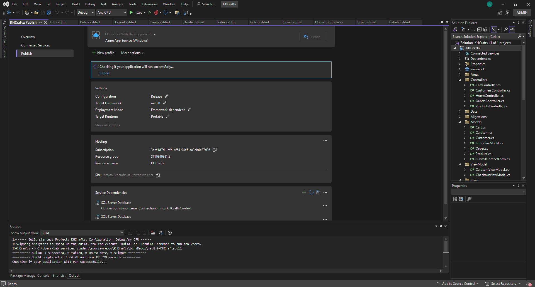

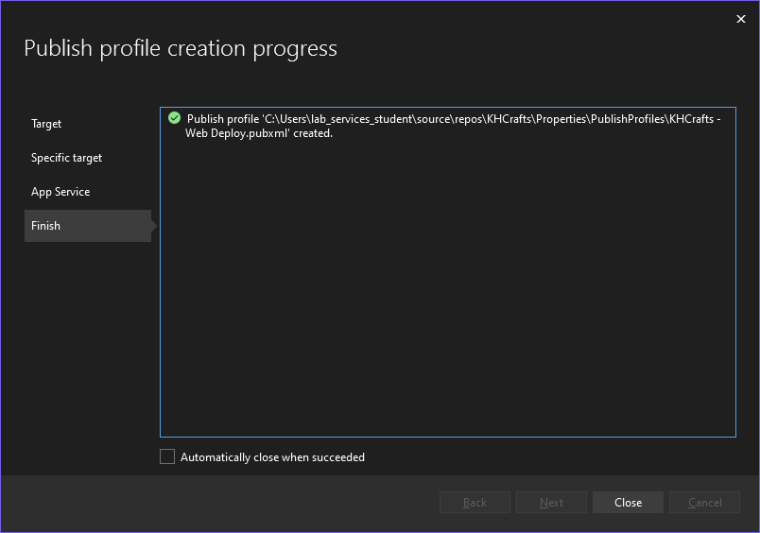

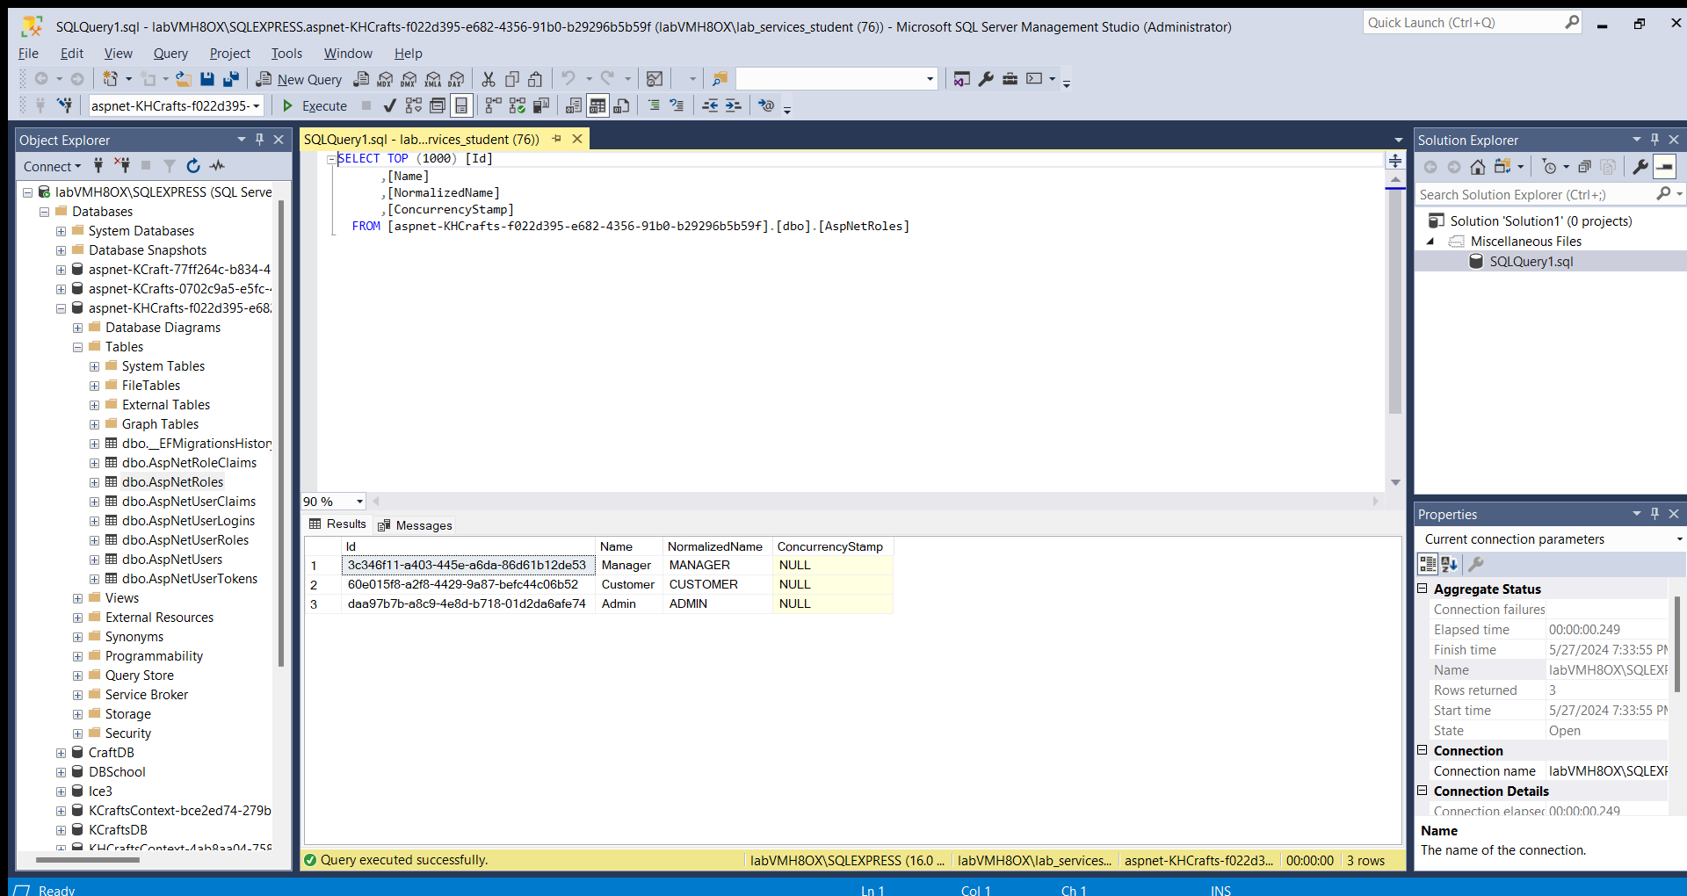

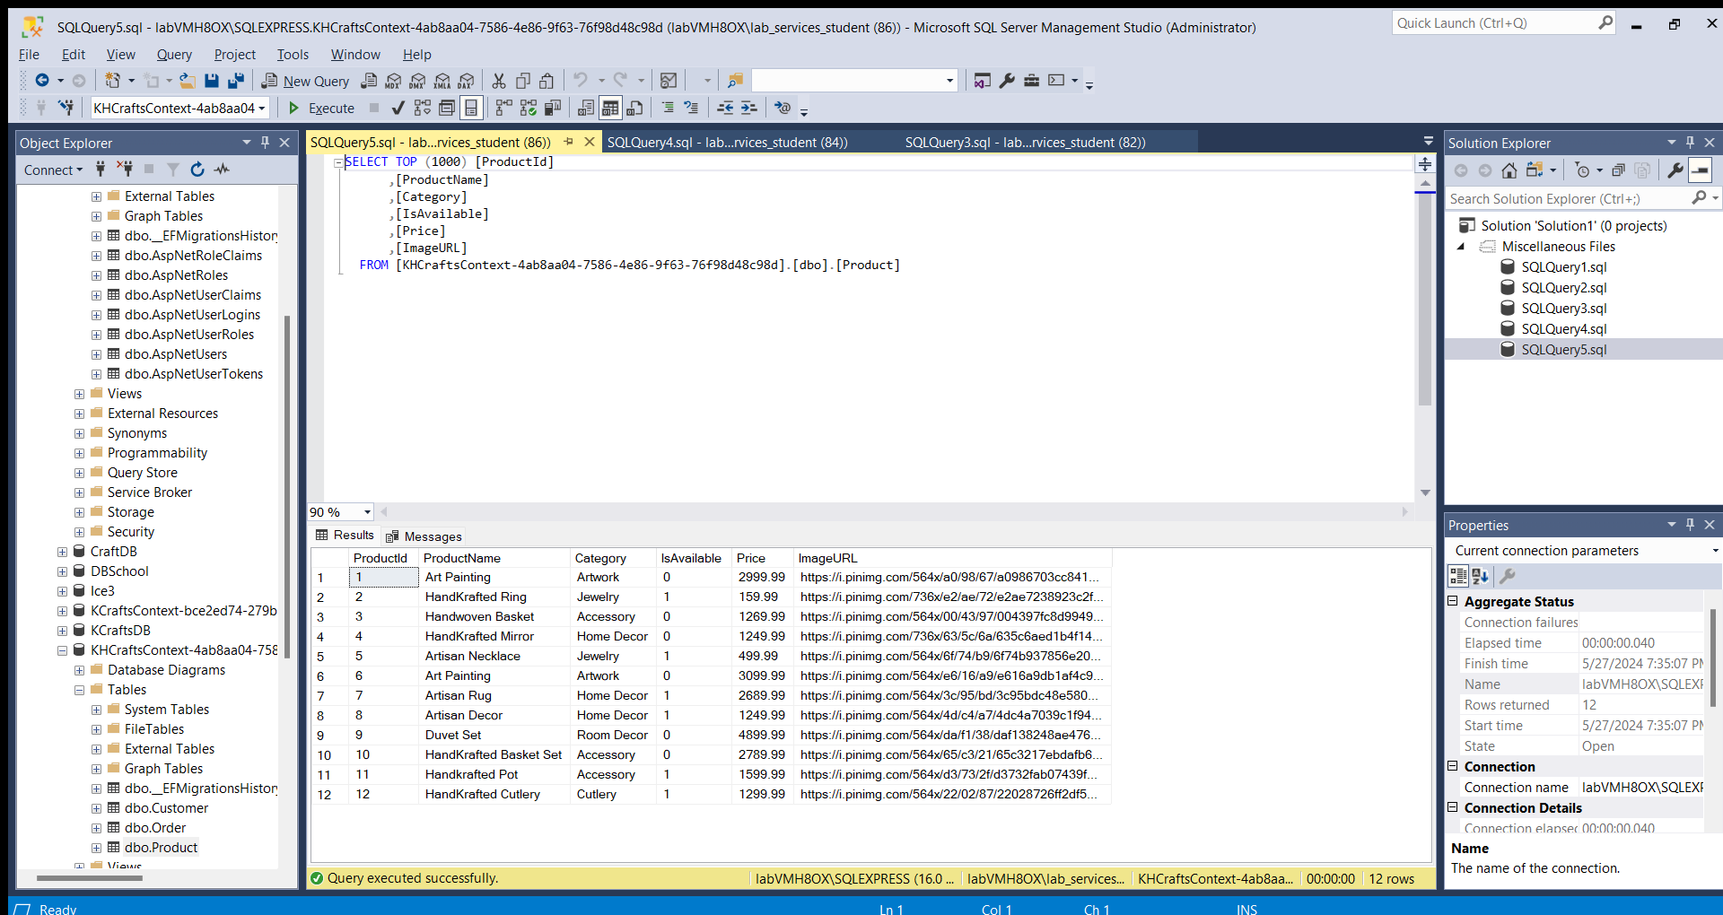

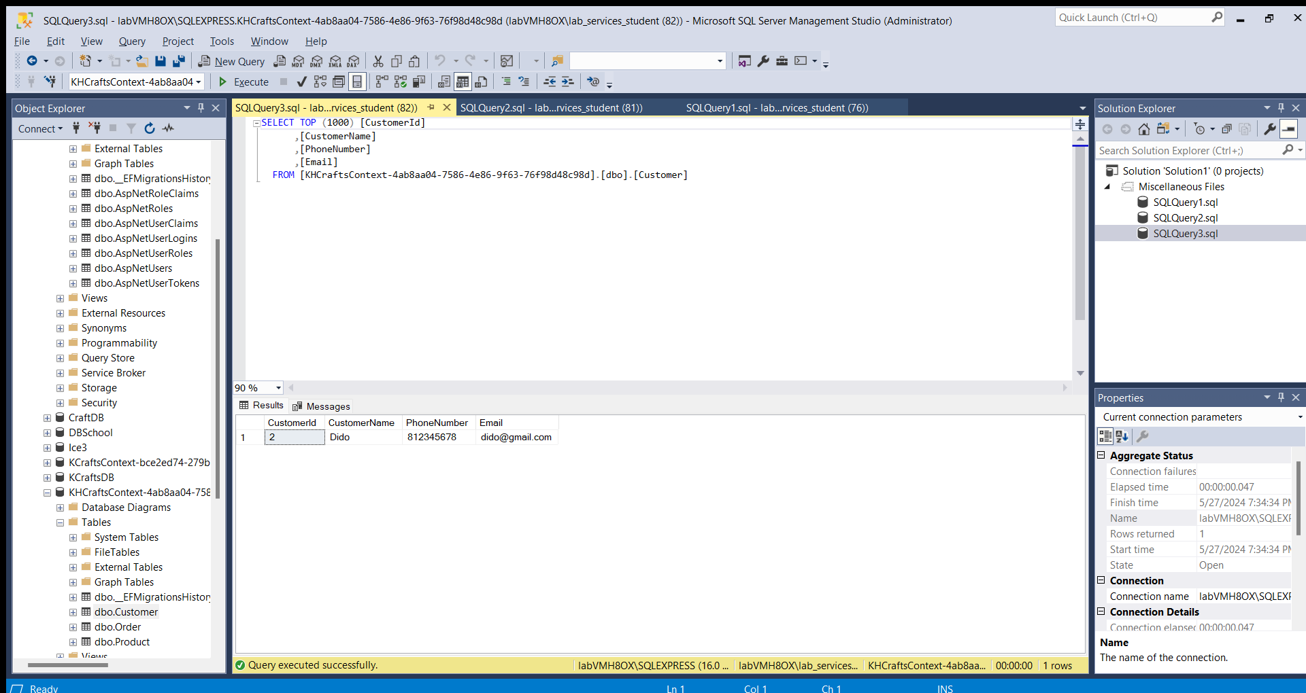

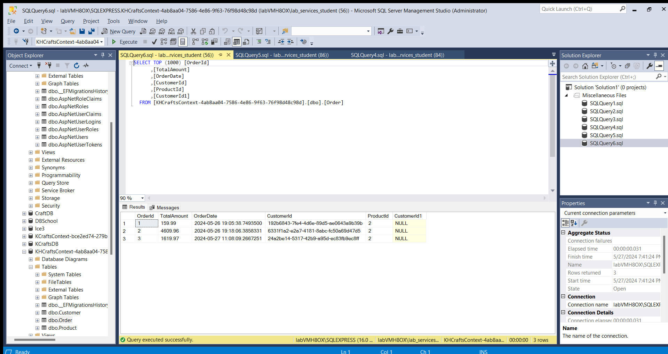

**ERD Diagram**

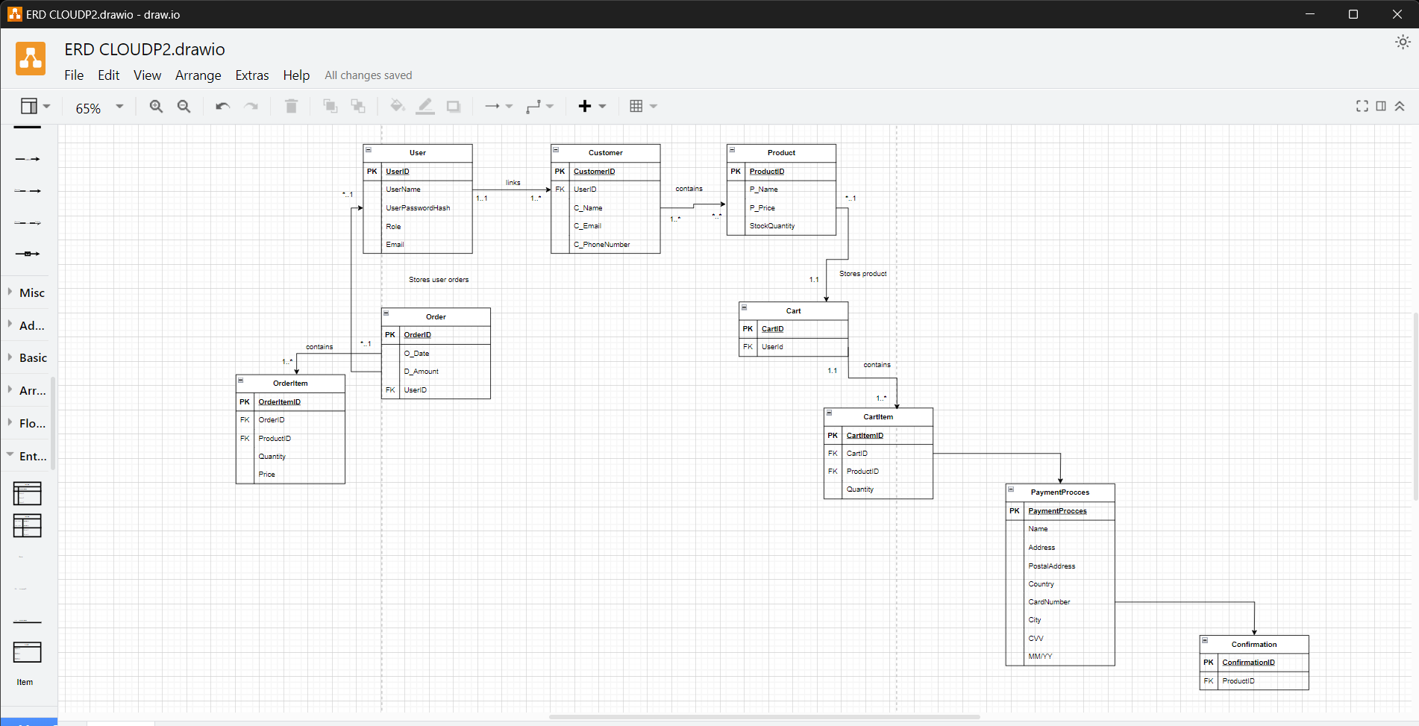

**Important Links**

Youtube link- <https://youtu.be/ZM3L2h6GFQw>

GitHub link - <https://github.com/st10390381/CLVD2.git>